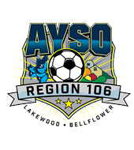 | Sponsored by AYSO Region 106 Lakewood-Bellflower, CA  23rd Annual Fox & The Hare Soccer Tournament  Open Team Invitation | 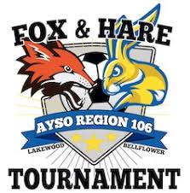

Scope: | AYSO INVITATIONAL: Open to all Spring Select, and Extra Teams from all Sections.
When: | Saturday & Sunday, May 4^{h} & May 5th - Rain or shine
Where: | The tournament will be held at Various Schools and Parks in the Lakewood – Bellflower, California area. Beyond our control some locations may charge for parking. Pets or BBQ’S are not allowed at fields.
Who: | AYSO boys and girls teams in age divisions: U19 (11V11) 18 players max, U-16 (11V11) 18 players max, U-14 (11v11) 15 players max. U-12 (9v9) 12 players max, U-10 (7v7) 10 players max, U-08 (7v7) 10 players max. All players must have been registered and played in the AYSO 2018 primary season, Guest players will be allowed (3 maximum per team). Co-ed teams will be accepted in boys divisions only.  In an effort to keep this a competitive tournament, for all levels, every effort will be made to place AYSO Extra teams in their own divisions: U16 (11v11) 18 players max, U14 (11v11) 15 players max, U13 (11V11) 15 players max, U12 (9V9) 12 players max, U11 (9V9) 12 players max, U10 (7V7) 10 players max, and U9 (7V7) 10 players max.
What: | Pool play tournament. Each team will be guaranteed 3 games in pool play. The top teams will advance to the medal round on Sunday. All games will be as follows: (70 min. for U-16, 60 min. for U-14, 50 min for U-12, and 40 min for U-10, U-9 & U-08). There is no advancement to medal round in U-08 division. All teams are guaranteed to play 3 games.
Why: | The Fox & The Hare Soccer Tournament is being conducted, as a fundraiser by Region 106 to raise funds to support our Spring Programs, High School Scholarships, and Region Equipment needs.
Awards: | All players and 2 coaches per team will receive a tournament pin. All players on the 1st, 2nd, & 3rd place teams will receive medals. Tournament Champions in each age division will receive a trophy/cup filled with candy. All players in the U08 Division will receive participation medals.
Entry Fee, Refunds: | Primary/Select: U-19 $600, U-16 $600, U-14 $600, U-12 $575, U-10 $550, U-8, $325 (Non-competitive).  Extra: U-19 $600, U-16 $600, U-14 $600, U-13 $600, U-12 $575, U-11 $575, U-10 $550, U-9 $550  A full refund will be issued if tournament is canceled. If a team withdraws prior to April 1, 2019, a full refund is given. No refund will be given to teams with drawing on or after April 1, 2019, unless a replacement team is found.

